

**GROUP ASSIGNMENT**

**TECHNOLOGY PARK MALAYSIA**

**AAPP012-4-2-RWDD-L1**

**RESPONSIVE WEB DESIGN AND DEVELOPMENT**

**HAND OUT DATE** **: Wednesday, 1st August 2024**

**HAND IN DATE** **: Sunday, 27th October 2024 @ 11:55PM**

**WEIGHTAGE** **: 100%**

**INTAKE** **: UCDF2304ICT(ITR)**

**DATE DUE** **: WEEK 13**

**DATE-ASSIGNED** **: WEEK 3**

Group members:

Chong Jun Meng –TP074139

Cheong Jing Lee –TP074711

CHUA CHUAN SENG –TP073332

Ng Jun Yuan -TP067314

Contents

Introduction/Project Plan 2

Objective 3

Scope 3

End-user specification 4

Major Functions 4

Background Analysis & Requirement Gathering 6

Background Analysis 7

Requirement Gathering 7

Design 8

Storyboard 9

Flowchart 13

ERD (ENTITY RELATIONSHIP DIAGRAM) 17

NAVIGATIONAL STRUCTURE(USER) 18

NAVIGATIONAL STRUCTURE(ADMIN) 19

Implementation 19

Conclusions 22

References 23

Workload matrix 24

# Introduction/Project Plan

## Objective

The objective of "Asia Pacific Traveler" is to provide a seamless online platform for users to explore and book curated travel experiences. Our website enables users to easily create accounts, browse travel packages, and complete secure online purchases. The platform integrates customer support features to assist users throughout their journey and includes a dedicated administrator interface with tools for efficient site management. This setup allows for ongoing updates, package management, and user engagement, ensuring a consistently high-quality experience for both travellers and site administrators.

## Scope

The "Asia Pacific Traveler" website is designed with functionalities tailored for both end-users and administrators.

For **users**, the site offers the following capabilities:

* **Viewing Packages**: Users can browse a variety of travel packages, view detailed descriptions, images and pricing.
* **View History**: Users can see their past purchases, claimed coupons and the packages they wish listed.
* **Making Purchases**: Through a secure purchasing process, users can select and reserve travel packages, with the requirement of logging in to ensure secure transactions.
* **Managing Accounts**: Registered users have access to a personalized account dashboard where they can review past purchases and view previously claimed coupons. Users can also update their own account information, ensuring their profile remains accurate and up to date for future transactions and communications.

For **administrators**, the site provides an efficient management system to ensure the platform remains up-to-date and relevant:

* **Updating Packages**: Administrators can easily add, edit, or remove travel packages, adjust prices, and update images and descriptions to reflect current offerings.
* **Updating Coupons**: Administrators can add, edit, or remove coupons by adjusting their discount percentage, maximum discount amount, and unique coupon code. Since coupons have no expiration date, administrators have flexibility in managing active deals to incentivize purchases, ensuring users always have access to beneficial offers without concern for time limits.
* **Updating User Information**: Administrators can modify user details, such as name email, and password.

## End-user specification

The primary users of the website include travel enthusiasts, families, budget travellers, and business travellers, all seeking to explore various destinations through appealing travel packages. Users expect a user-friendly interface that allows for seamless browsing and easy access to relevant information, ensuring that they can quickly find packages that meet their needs. Comprehensive details about each travel package, including itinerary specifics, pricing, accommodations, and included services, are crucial for informed decision-making. Additionally, users anticipate a secure purchasing process that safeguards their personal and payment information.

To enhance their experience, users look for personalized features such as account management, where they can view their purchase history, wish listed packages, and claimed coupons. The website meets these needs by providing an intuitive layout and easy navigation, allowing users to explore different travel options effortlessly. Each package includes detailed descriptions, further assisting users in making informed choices. Furthermore, the website is designed to be mobile-responsive, ensuring that users can conveniently access and browse travel packages from any device.

## Major Functions

**User Account Management**

* **Function**: Users can create accounts, log in, and manage their account information.
* **Purpose**: Enables personalized experiences and secure access to purchase history
* **Details**: Includes form validation and password security

**Package Viewing and Filtering**

* **Function**: Display available travel packages with filters by region.
* **Purpose**: Enables users to efficiently find travel packages that are specific to their desired region, streamlining the search process and improving overall navigation within the site.
* **Details**: Showcases packages in a visually appealing layout, with thumbnail images, package names, and pricing.

**Package Detail and Booking System**

* **Function**: Allows users to view detailed information on each package and initiate a booking.
* **Purpose**: Provides users with complete information to make purchasing decisions and initiates the purchase process.
* **Details**: Includes package images, descriptions, price, and a “Reserve Now” button.

**Admin Dashboard for Content Management**

* **Function**: Provides administrators with tools to add, update, and delete travel packages and coupons, as well as update user information.
* **Purpose**: Facilitates efficient management of travel packages and coupons, enabling staff to maintain up-to-date offerings and ensure accurate user information on the website.
* **Details**: Includes options to upload images, edit package descriptions, and update coupon information and user accounts.

**History and Account Management for Users**

* **Function:** Provides users with easy access to view their purchase history, wishlisted packages, and claimed coupons, each through dedicated pages accessible from their account.
* **Purpose:** Enhances user satisfaction by organizing and streamlining access to past purchases, claimed coupons, and wish listed packages in a clear, user-friendly manner.
* **Details:** Users can view previous purchases with information such as trip details, location, and images on a dedicated purchase history page. Separate pages also display lists of claimed coupons and wish listed packages, giving users a comprehensive and organized view of their account activity.

# Background Analysis & Requirement Gathering

## Background Analysis

In reviewing similar travel package websites such as Trip.com and Agoda, several effective practices and trends emerge that significantly enhance user satisfaction and engagement. Both platforms are optimized for mobile devices, allowing users to browse and book travel packages easily on smartphones and tablets. This mobile-first approach is essential as more users rely on their devices for travel planning. Öncüler (2024) emphasizes that mobile devices now account for a substantial portion of travel-related searches and bookings, underscoring the importance of mobile responsiveness for user convenience and accessibility.

These websites also feature user-centric designs with clean layouts and intuitive navigation, enabling users to explore various travel options easily. According to Codetheorem (2024), users often arrive on travel websites seeking inspiration and recommendations, rather than being set on a single destination. This aligns with the effective use of filters, such as those for price and destinations, which help users quickly locate packages that match their interests, fostering a more engaging browsing experience.

Additionally, high-quality images, detailed package descriptions, and user reviews are prominently displayed, building trust and providing essential information that influences purchasing decisions. Both platforms also offer personalized recommendations based on user behaviours, past searches, and preferences, further enhancing user engagement and satisfaction.

## Requirement Gathering

Imagining feedback from clients and hypothetical users reveals several essential needs and preferences that the website must address to provide a satisfying user experience. First and foremost, users expect a user-friendly interface featuring a clean layout and intuitive navigation, which will enhance their overall browsing experience. This will enable users to find and explore travel options easily and efficiently.

Mobile responsiveness is also critical; the website should be fully functional on mobile devices, ensuring a seamless experience for users on smartphones and tablets. As more individuals rely on their devices for travel planning, this feature becomes essential for catering to a broader audience.

In addition, users require robust account management features that allow them to create and manage their accounts effectively. This functionality should enable users to keep track of their purchases, Wishlist, and claimed coupons easily, enhancing their interaction with the website.

Comprehensive package information is crucial for each travel option. This includes detailed descriptions, high-quality images, and transparent pricing, all of which help users make informed purchasing decisions.

Lastly, to facilitate efficient browsing, the website must include effective search and filter options, allowing users to narrow down packages based on destination. By addressing these requirements, the travel package website can significantly enhance user satisfaction and improve the overall experience.

# Design

## Storyboard

1. This is the homepage it acts as a hub to other webpages. To get to the package trip page, click on this button

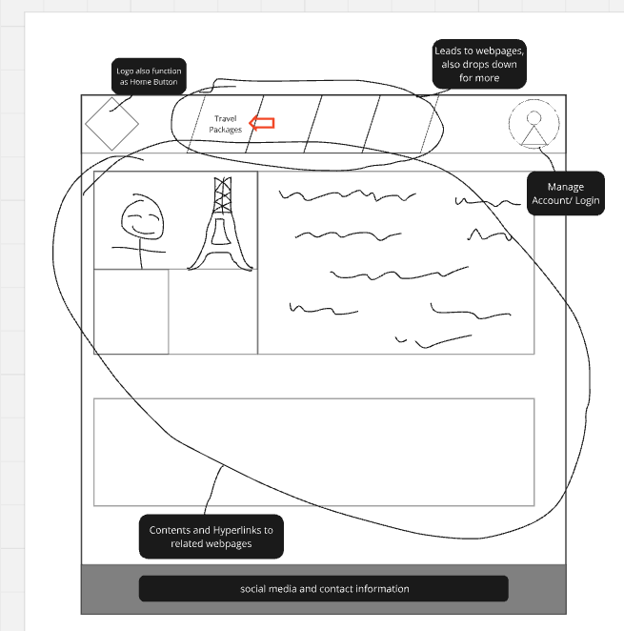

2. Click on one of the packages

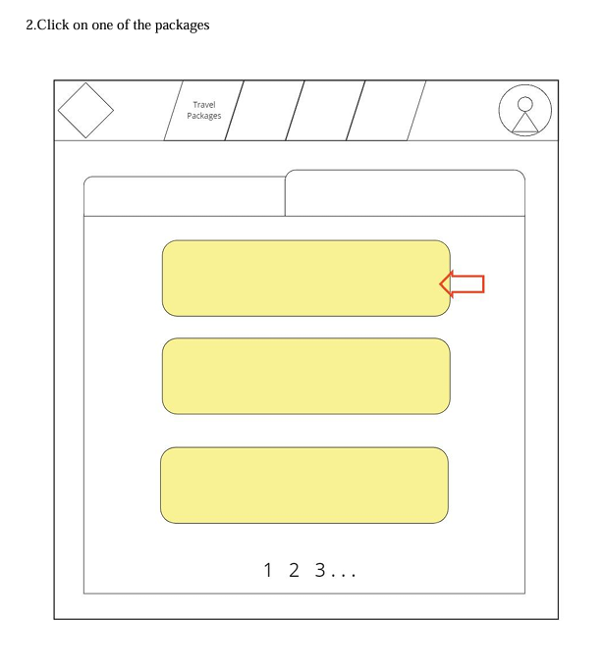

3. Then you will be able to view the details and pictures of the packages. Press the reserve now button to continue

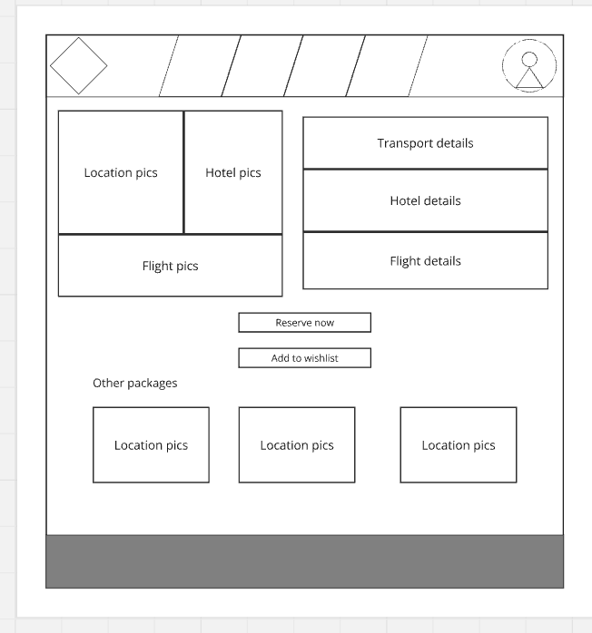

4. Once pressed, key in the required information to complete the purchase.

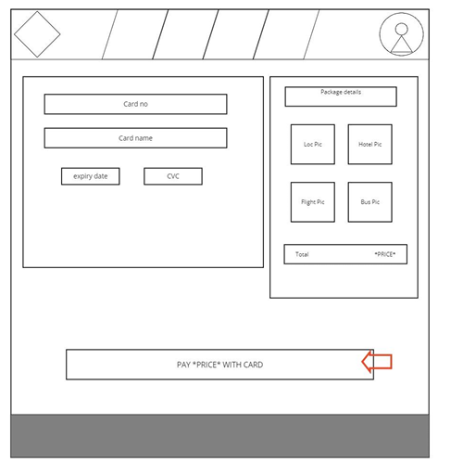

5. Lastly, user will be directed back to the homepage.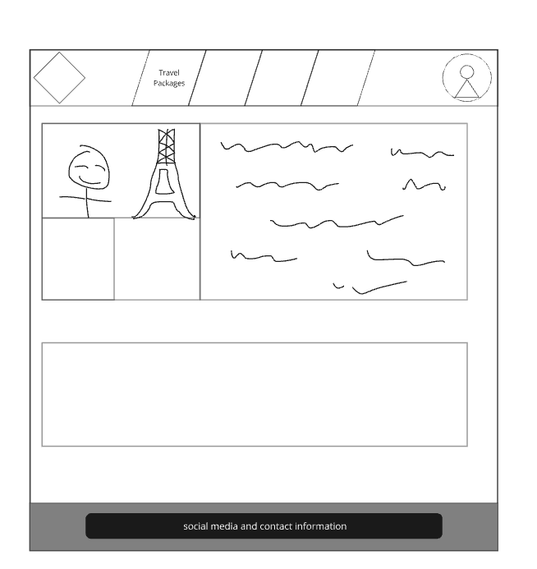

## Flowchart

Figure 1: The flowchart about Customer chooses and buy a travel package

In this case, Customer needs to login to view the package and buy the package. If customer did not login, website will pop up the message to login, if the customer has not account to login, customer will lead to form the new Asia Pacific Traveler account. Then, when customer login, website will check is the account information this right or not. If true, then customer can be ongoing to process and if false then website will let the customer fill the account information again. Customers can then choose their travel package and then make a purchase. The difference between purchasing local travel packages and foreign travel packages step is that you do not need to provide your passport number to purchase travel packages, while you do need to provide your passport number to purchase foreign travel packages. After the final customer pays, the webpage will give this account a new purchase package record.

Figure 2: The flowchart about the customer visits the Asia Pacific Traveler.

When a customer visits a page, he can see the home page with navigation structure. if the visitor wants to go any navigation structure besides FAQ, They must log in. If the visitor has an account, the visitor will enter id and password. If it is correct, he will be able to continue to visit all navigation in Asia Pacific Traveler, otherwise must re-enter his id and password again. If the visitor doesn't have an account, he needs to set up a new account and store it in the database and create a new account. After setting up an account, visitor will return to the home page.

Figure 3: The flowchart about the coupon setup in admin side.

This flowchart details the process administrators follow to configure coupons in the system. The flow begins with the admin logging into the system and accessing the coupon setup page. Here, the admin can input details for new coupons, such as the discount amount, expiration date, and terms of use. After entering the necessary information, the admin saves the settings, which triggers the system to validate all entries for accuracy. If there’s an error or missing information, the admin receives a prompt to make corrections; otherwise, the system confirms and activates the coupon.

Figure 4: The flowchart about the coupon setup in user side.

This flowchart illustrates the steps a user takes to apply a coupon within the system. The user starts by logging into their account and selecting a desired service or product. During the checkout process, the user enters the coupon code in the designated field. The system then verifies the coupon for eligibility, checking conditions like expiration date and applicable items. If the coupon is valid, the system calculates and applies the discount to the total price; if not, it notifies the user of any issues with their entry.

## ERD (ENTITY RELATIONSHIP DIAGRAM)

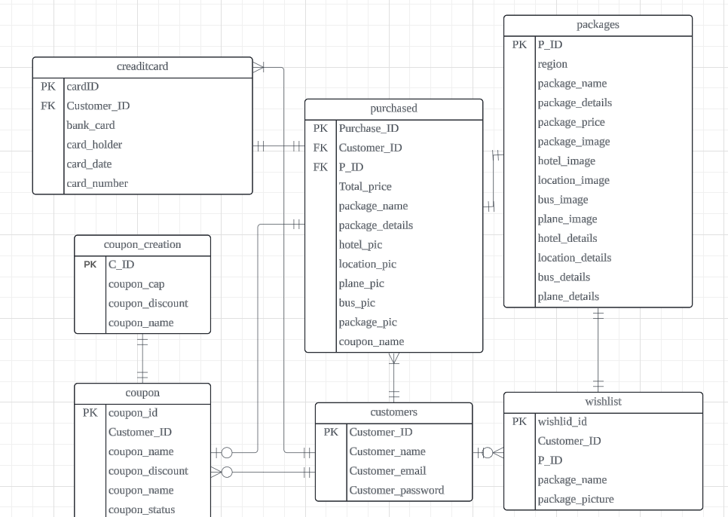

## NAVIGATIONAL STRUCTURE(USER)

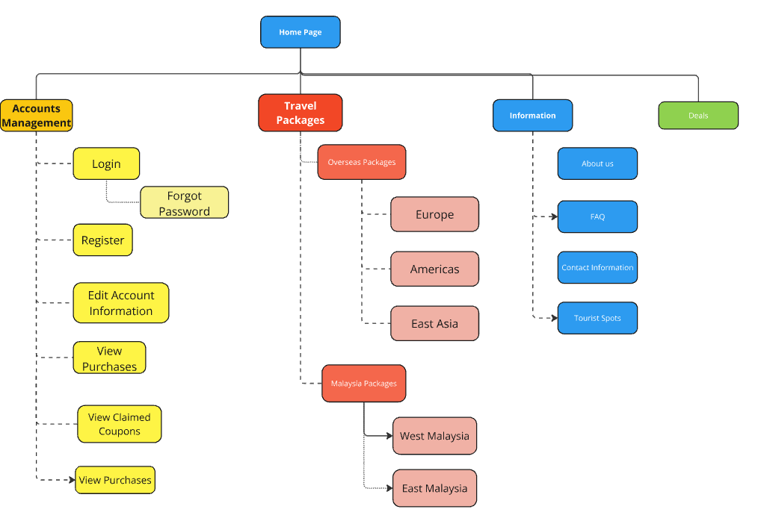

## NAVIGATIONAL STRUCTURE(ADMIN)

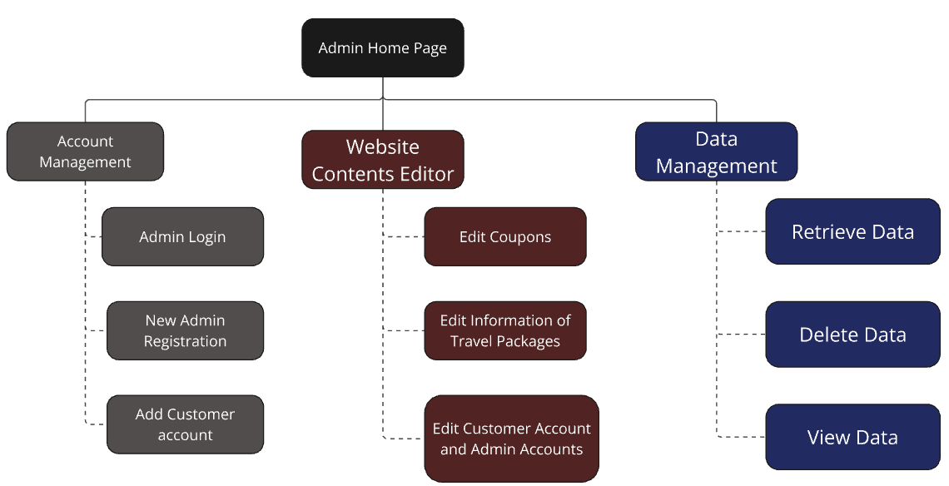

# Implementation

**Key Steps for Developing the Project:**

1. **HTML Structure:** The first step in the implementation process involved creating a solid HTML structure to define the layout and content of the website. This included establishing the primary elements such as the logo, navigation menu, main content area, and footer. The navigation menu was built using an unordered list, allowing for a multilevel dropdown structure to organize links effectively.

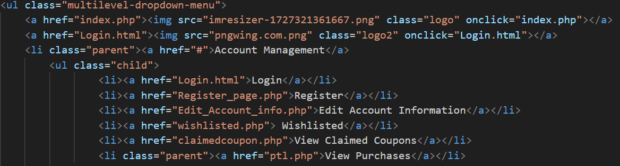

The footer was constructed using a div elements, consistently displaying a message thanking visitors for choosing Asia Pacific Traveler and including the copyright information for 2024.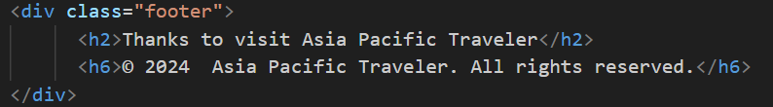

1. **CSS Styling:** Following the HTML structure, CSS was utilized to style the website, enhancing its visual appeal and user experience. This included defining typography, colors, and spacing to create a cohesive look throughout the site. Key UI components, such as buttons and forms, were styled to ensure consistency and improve usability.
2. **Responsive Design:** Media queries were employed to make the website responsive, allowing it to adapt to various screen sizes and orientations. Breakpoints were established for common device sizes (e.g., mobile phones, tablets, and desktops), ensuring that users could enjoy a seamless experience regardless of their device. This involved adjusting layout properties, font sizes, and element visibility based on the viewport width.
3. **JavaScript Functionality:** JavaScript was integrated to add interactivity to the website, primarily focusing on dynamic content updates. A key feature is the slideshow component, allowing users to navigate through images seamlessly with real-time updates. The showSlides function, as shown below, adjusts the current slide and updates visual indicators based on user actions. When plusSlides(n) is triggered, for example, the slideshow index is incremented or decremented without requiring a page reload, creating a smoother user experience.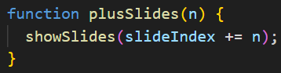

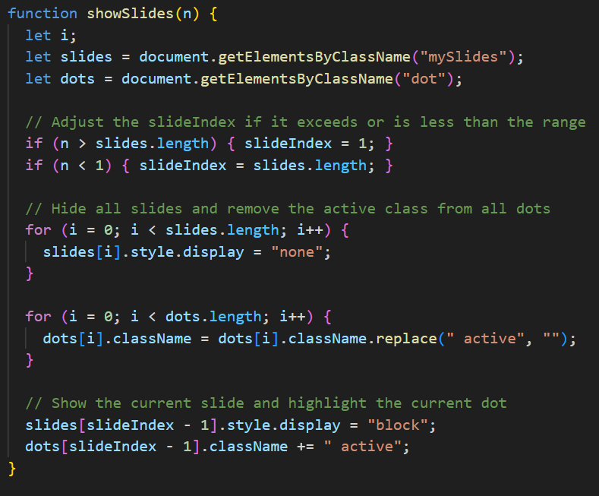

This JavaScript functionality enhances user engagement by allowing content updates directly within the page, ensuring a more seamless and interactive experience as users browse the slideshow or other dynamic elements on the website.

1. **PHP Integration:** PHP was utilized extensively to dynamically generate and manage content based on user actions, including the display of available travel packages. For instance, PHP retrieves package information from the database based on a user’s selection, processing this data to render details like the package name, price, location, and an image. If no packages are available, a message is displayed to inform the user. This integration ensures that relevant content is dynamically fetched and presented to enhance user engagement. The following code demonstrates this dynamic package generation:

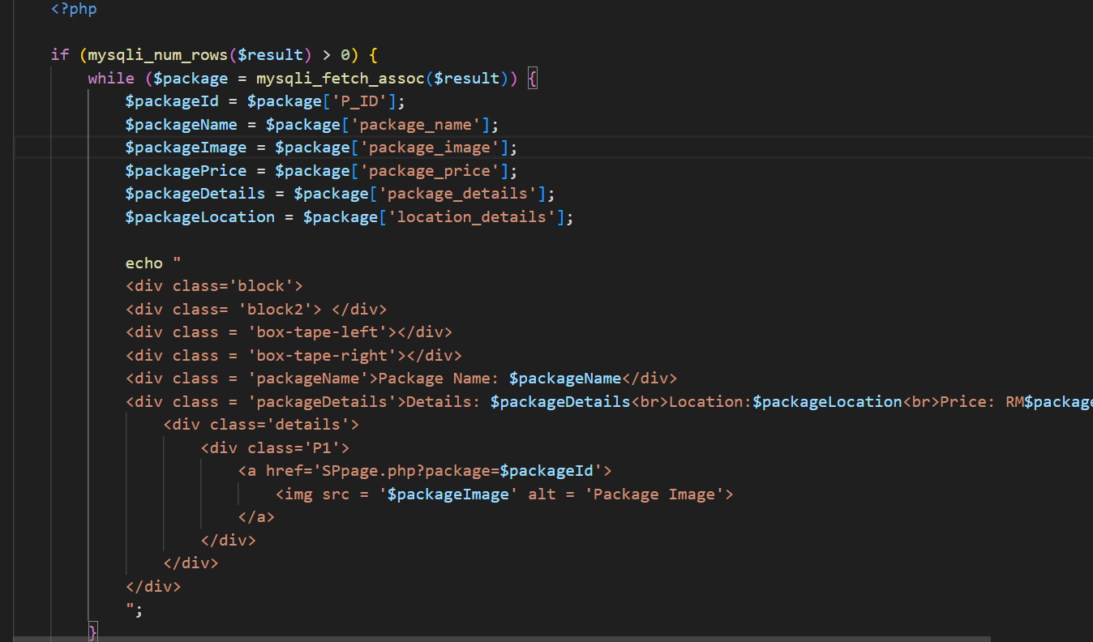

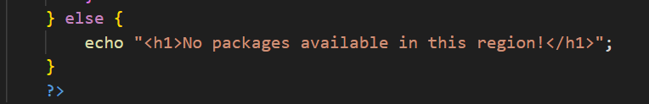This code highlights how PHP dynamically generates each package’s HTML structure based on the retrieved data, ensuring that users always have access to the most relevant information.

# Conclusions

In conclusion, the development of the "Asia Pacific Traveler" website successfully achieved the main objectives by providing a user-friendly platform that enables seamless browsing, account management, and secure purchasing of travel packages. The website incorporates essential features like an organized package display, filtering options, secure account management, and a responsive design, making it accessible across various devices. Additionally, the admin dashboard allows for efficient management of packages and coupons, meeting the project’s goals for user engagement and operational ease.

However, some limitations persist, particularly in the need for more personalized user recommendations based on past activities and a limited range of payment options, which could affect user experience and conversion rates. Future improvements could address these issues by implementing recommendation algorithms and expanding payment methods, such as mobile wallets or international payment options, to cater to diverse user preferences. Further, enhancing the website's speed and integrating a multilingual option would significantly improve accessibility and usability for a broader audience. Addressing these limitations would elevate the platform, making it a more comprehensive and appealing tool for user and admin alike.

# References

Öncüler, U. (2024, March 1). *Mobile optimization for travel websites (2024)*. 618Media: #1 Digital Marketing Agency. <https://618media.com/en/blog/mobile-optimization-for-travel-websites/#the-importance-of-mobile-optimization>

Codetheorem. (2024, June 14). *12 must have key features for your Travel Website*. Blog. <https://codetheorem.co/blogs/must-have-features-for-travel-website#:~:text=When%20users%20land%20on%20your%20travel%20website%20they,the%20right%20questions%20with%20clear%20and%20compelling%20filters>.

# Workload matrix

|  |  |  |  |
| --- | --- | --- | --- |
| Name | TP number | Workload | Signature |
| Chong Jun Meng | TP074139 | Coupon Page, TPL page, SP page, Checkout Page, Admin Edit Package Page, Admin Add Package Page, Admin Edit Coupon Page, Admin Edit Coupon Page | Chong Jun Meng |
| Cheong Jing Lee | TP074711 | Wish listed page, Tourist Spot Page | Cheong Jing Lee |
| CHUA CHUAN SENG | TP073332 | Past Trip Listing, Past Trip Details page, Support Page | Chua Chuan Seng |
| Ng Jun Yuan | TP067314 | Edit Account Information Page, Login Page, Register Page, Admin Home Page, Admin Add Account Page, Admin Account Management Page, Navigational Bar, Footer | Ng Jun Yuan |